Lab 9
Cloning the Depth-Anything repository and creating the Conda environment with Python 3.10.
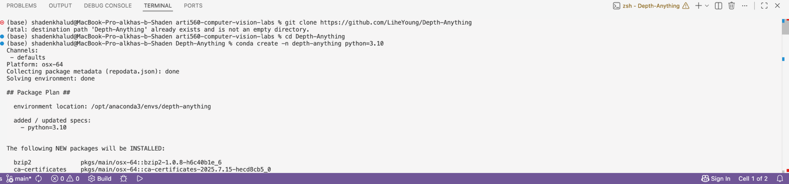
Activating the conda environment and installing all required packages via pip install -r requirements.txt
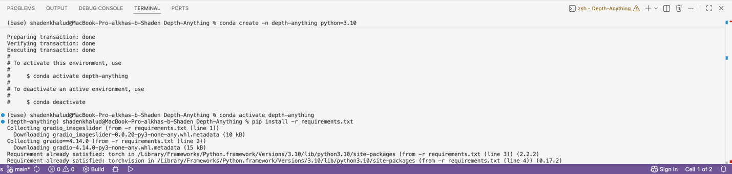

Grayscale Depth Map (Terminal & Output )
Right side shows the grayscale depth map where brighter >> closer, darker >> farther
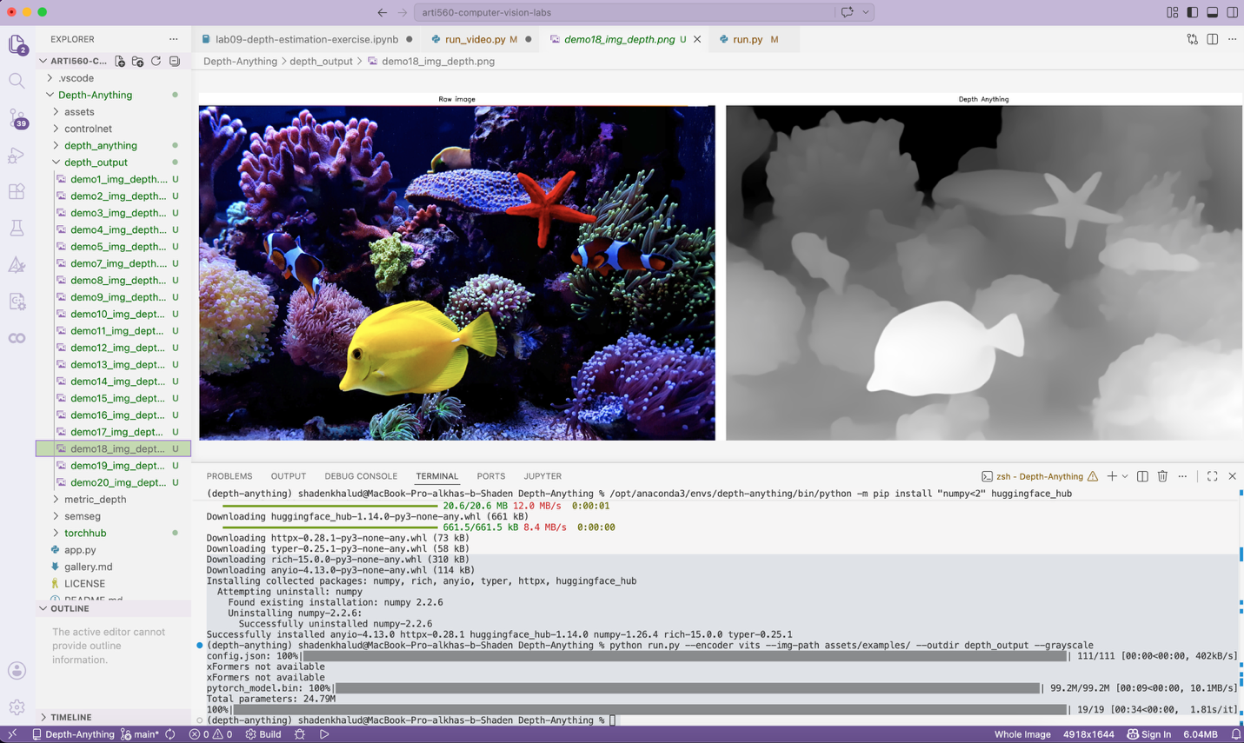

Color Depth Map (Terminal & Output)
Warm colors (yellow/orange) indicate closer objects while Cool colors (purple/black) indicate farther objects
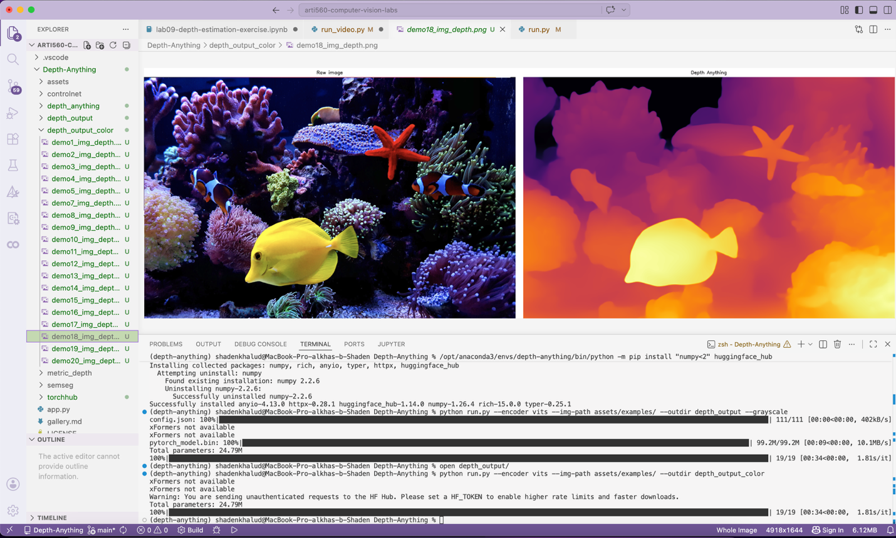
Another Color Depth Map (Output Only)
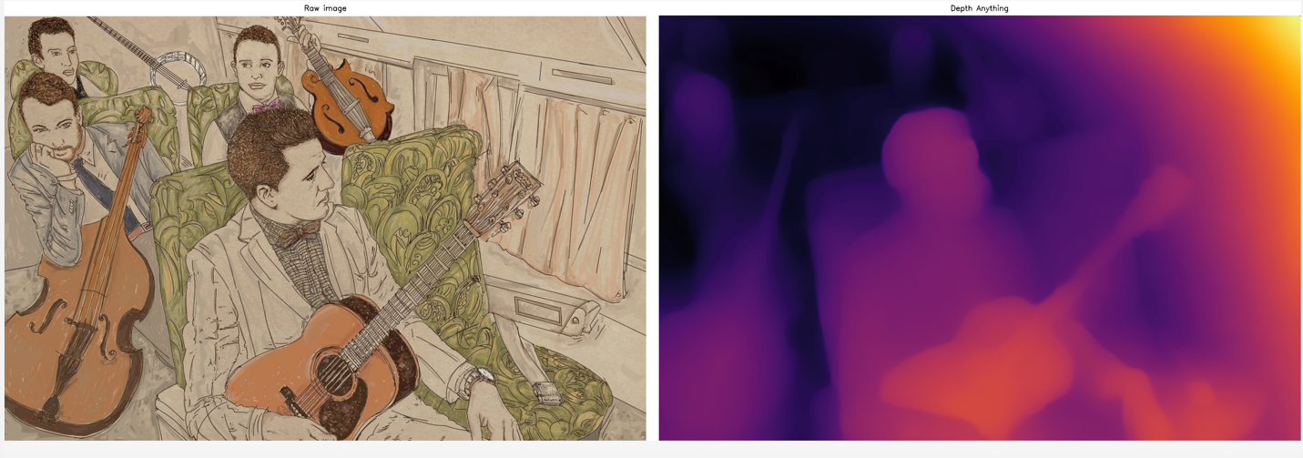

Video Depth Estimation
depth estimation on davis_dolphins.mp4
output video shows side-by-side the original footage (left) and color depth map (right), with dolphins appearing as warm-colored foreground objects
